Private Letter Ruling
Ruling Number: | P-2016-007

Tax Type: | Individual Income Tax
Brief Description: | Taxation of BNSF Retirement Plan Pensions
Keywords:
Effective Date: | 08/16/2016
Approval Date: | 08/16/2016

Body:
August 16, 2016
XXXXXXXXXX
XXXXXXXXXX
Re: Kansas Income Tax
Dear XXXXX
Your correspondence of August 11, 2016, has been referred to me for response. Thank you for your inquiry.
By your e-mail you have requested our advice regarding Kansas income tax. Specifically, your e-mail states:
Can't seem to find any information on this. Wondering if the BNSF Retirement Plan pension is exempt from Kansas state tax as well as a pension from the RRB Railroad Retirement Board? Is there a list somewhere listing all allowable exempt pensions to Kansas?
As you may be aware, Kansas law requires the use of federal adjusted gross income as the starting point for computing the Kansas income tax. Then certain modifications, either additions or subtractions, may be required. In the absence of a specific modification those items which are subject to federal tax will be subject to Kansas tax, and those items which are exempt from federal tax will be exempt from Kansas tax.
There is a subtraction modification permitted under Kansas law that relates to pensions from the Railroad Retirement Board. As a result, these benefits are exempt from Kansas income tax. However, there is no specific modification for retirement benefits received from a BNSF retirement plan. As a result, if these benefits are included in federal adjusted gross income they will be subject to Kansas income tax.
I trust this information is of assistance. If I can be of further service, please feel free to contact me.
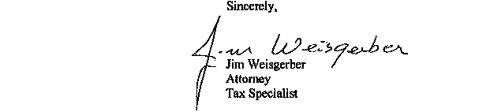
JW:jw
NOTE: This opinion letter is based solely on the facts provided in your request for advice. If material facts or information were not disclosed this letter is null and void. This letter will be revoked without further action by the Department if the statutes, administrative regulations, published revenue rulings, or court decisions that materially affect this opinion are changed.
Date Composed: 09/16/2016 Date Modified: 09/16/2016

