Private Letter Ruling
Ruling Number: | P-2016-002

Tax Type: | Individual Income Tax
Brief Description: | Pension Distribution from Kansas National Education Association
Keywords:
Effective Date: | 07/19/2016
Approval Date: | 07/19/2016

Body:
July 19, 2016
XXXXXXXXXX
XXXXXXXXXX
XXXXXXXXXX
XXXXXXXXXX
XXXXXXXXXX
XXXXXXXXXX
Re: Kansas Income Tax
Dear XXXXX:
Your correspondence of July 7, 2016, addressed to Mr. Bob Clelland has been referred to me for response. Thank you for your inquiry.
By your e-mail you have requested our advice regarding Kansas income tax. Specifically, your e-mail states, in pertinent part:
. . . . . I have a question that I thought maybe you could give me some guidance. Kansas allows a subtraction for personal income tax purposes for certain types of retirement income. I have an individual that received a pension distribution from the Kansas National Education Association. I'm not certain whether that falls in one of the enumerated categories of subtractions from income. Would you have any specific knowledge of this or at least be able to give me a statutory reference so that I could research it more thoroughly myself?
As you are no doubt aware, Kansas law requires the use of federal adjusted gross income as the starting point for computing the Kansas income tax. Then certain modifications, either additions or subtractions, may be required in accordance with K.S.A. 79-32,117. In the absence of a specific modification under K.S.A. 79-32,117 those items which are subject to federal tax will be subject to Kansas tax and those items which are exempt from federal tax will be exempt from Kansas tax.
K.S.A. 79-32,117 does not include a specific subtraction modification for pension distributions from the Kansas National Education Association. And we are not aware of any enumerated modification which would apply to such distributions. As a result, unless you (the taxpayer) are able to provide some proof or documentation that the distributions do fall under a specific subtraction modification listed in the statute these payments will be included in Kansas adjusted gross income and will be subject to Kansas income tax.
I trust this information is of assistance. If I can be of further service, please feel free to contact me.
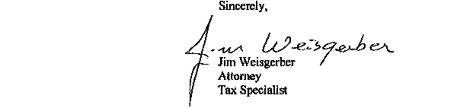
JW:jw
NOTE: This opinion letter is based solely on the facts provided in your request for advice. If material facts or information were not disclosed this letter is null and void. This letter will be revoked without further action by the Department if the statutes, administrative regulations, published revenue rulings, or court decisions that materially affect this opinion are changed.
Date Composed: 09/16/2016 Date Modified: 09/16/2016

